Bimetallic Thermometer
# Source: AI Source: Provided by: [Data Path: Persons Table -> ID Column: 1, Name_En Column: Motasem Essam] -> From: [ChatGPT] on [7/17/2026]
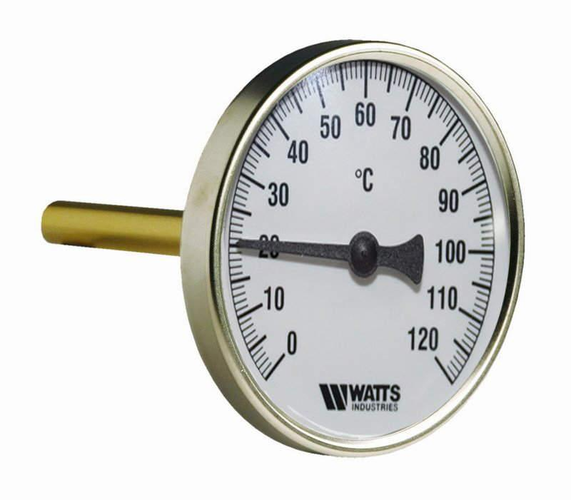
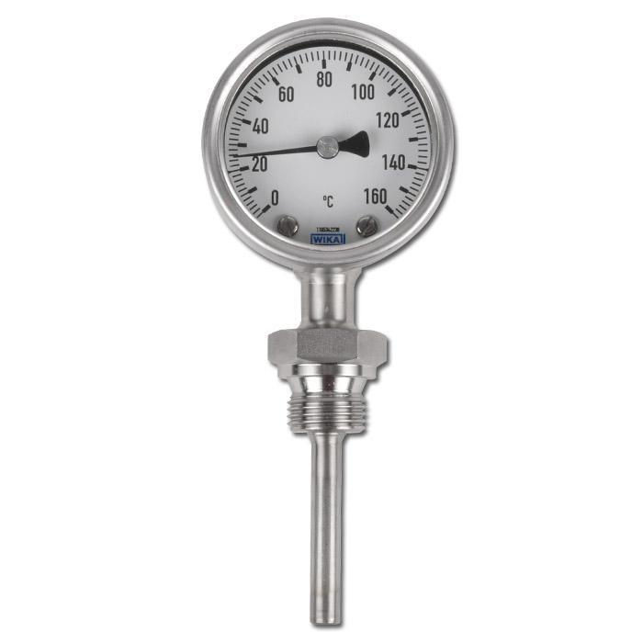
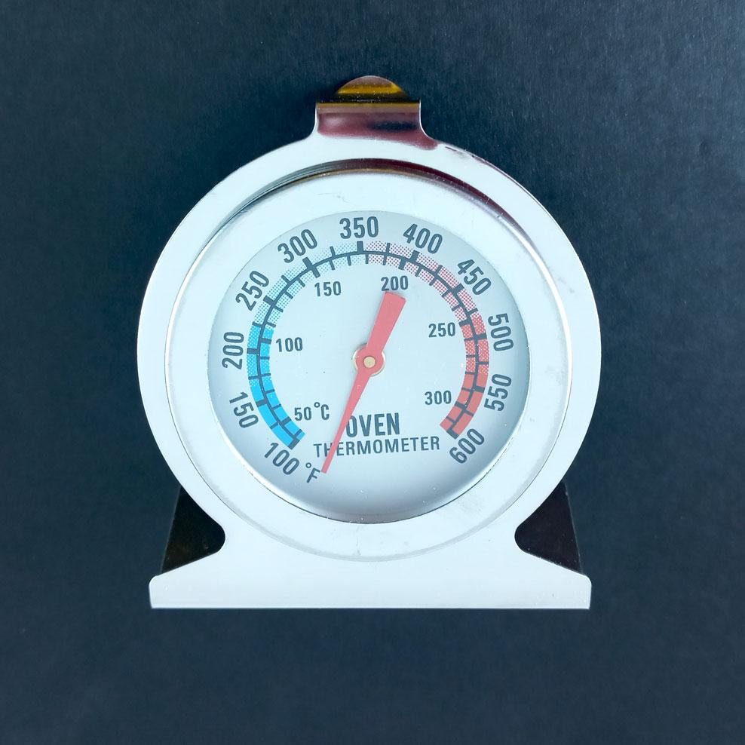
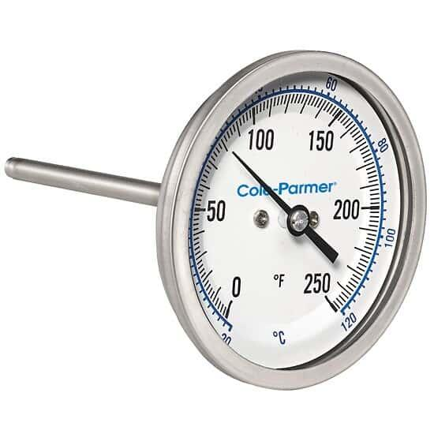
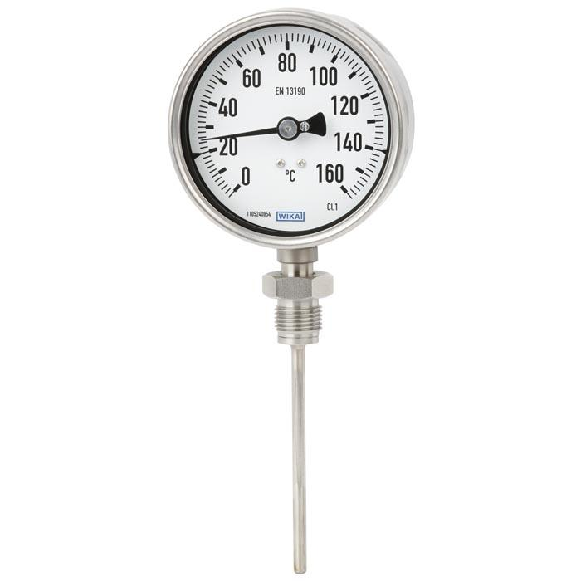
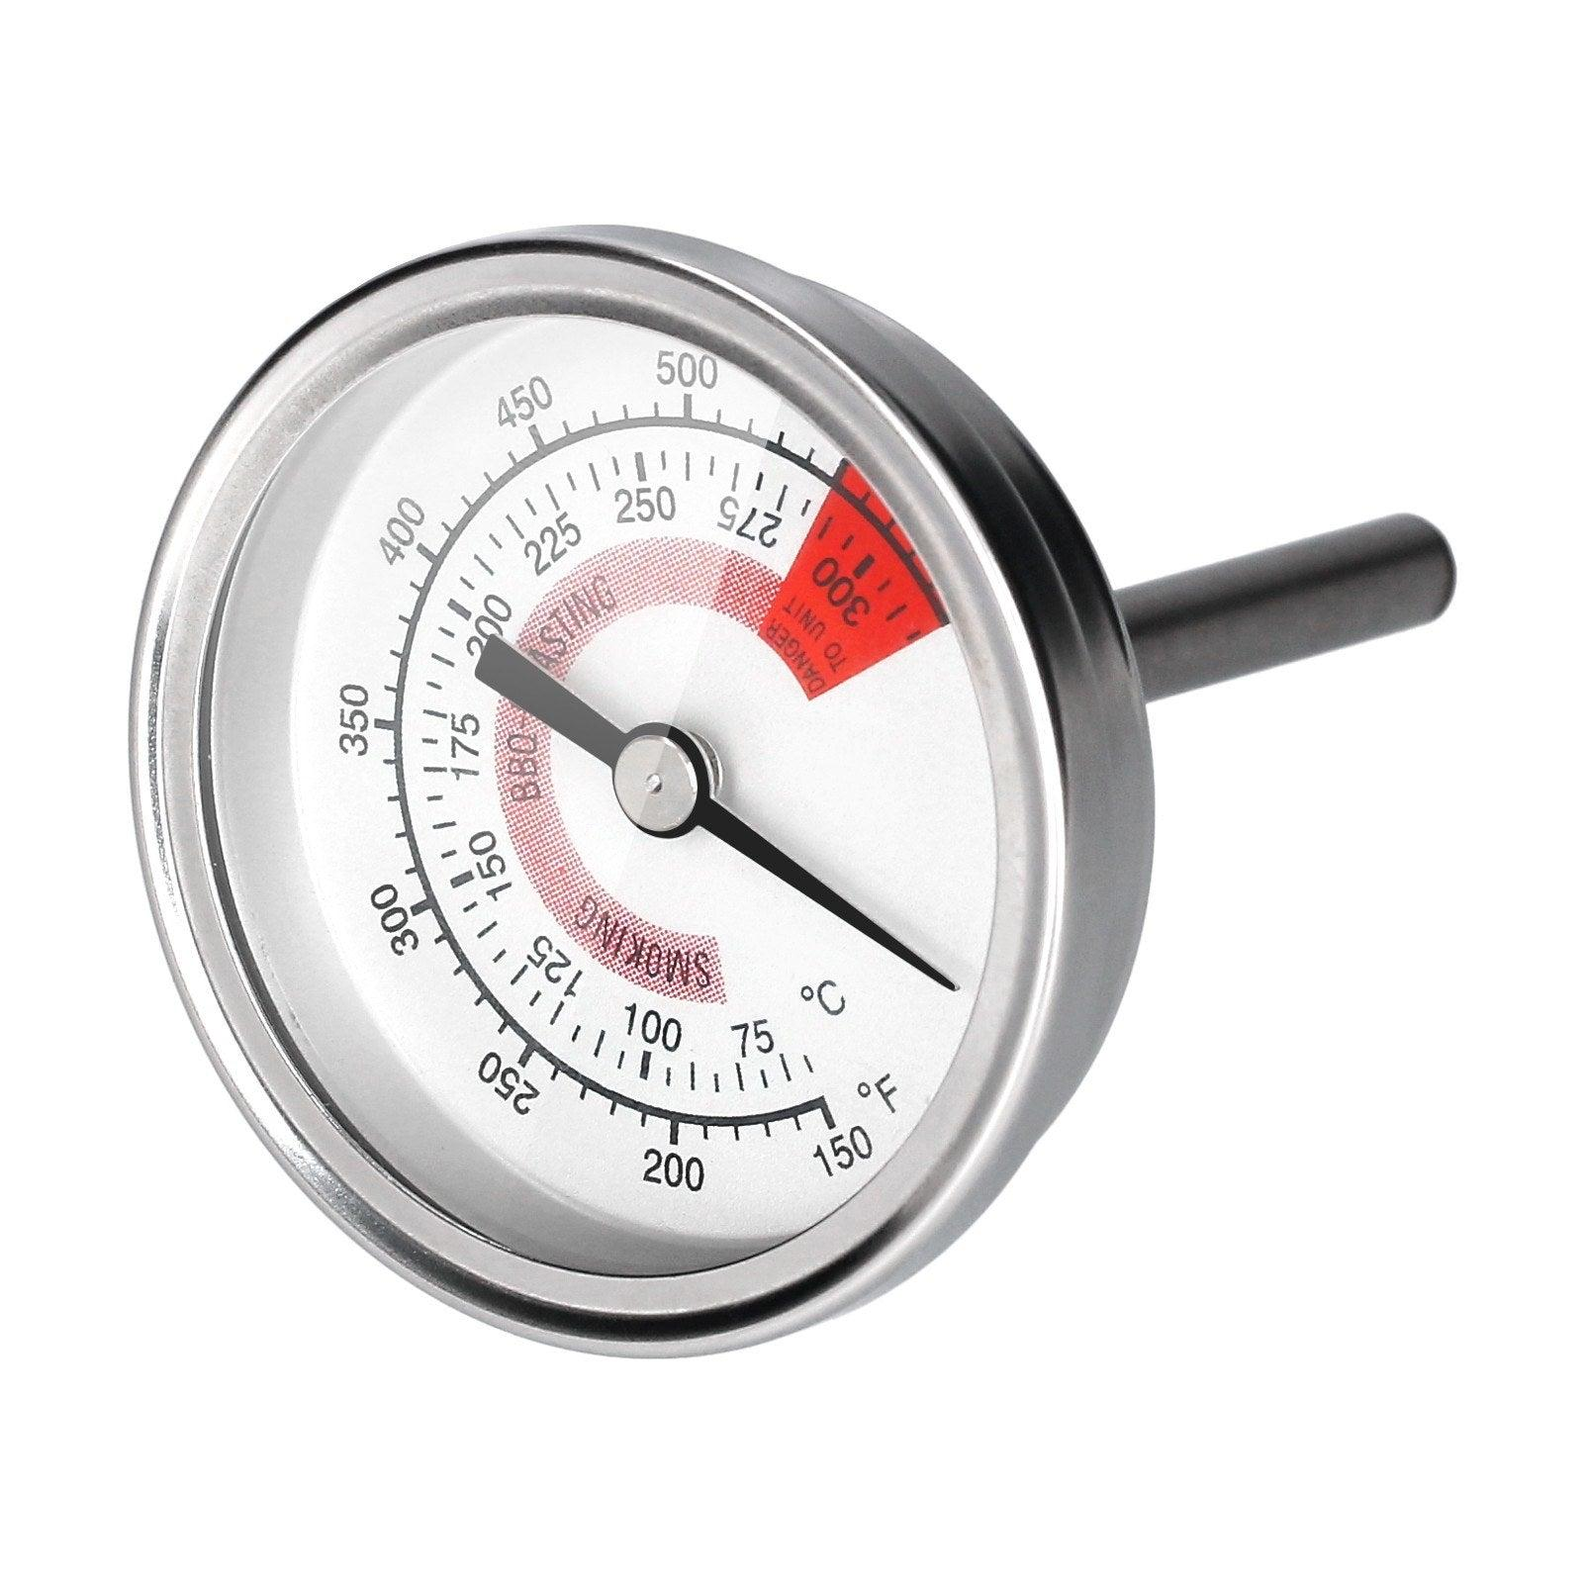
A Bimetallic Thermometer is a mechanical temperature-measuring instrument that uses the different thermal expansion rates of two bonded metal strips to indicate temperature. It is widely used in HVAC systems, industrial equipment, boilers, ovens, refrigeration systems, food processing, and process industries because it is durable, reliable, and does not require electrical power.

Definition
# Source: AI Source: Provided by: [Data Path: Persons Table -> ID Column: 1, Name_En Column: Motasem Essam] -> From: [ChatGPT] on [7/17/2026]
A Bimetallic Thermometer is a temperature-measuring instrument that uses a bimetallic strip or coil, made of two different metals bonded together, to measure temperature through mechanical movement.

Purpose
# Source: AI Source: Provided by: [Data Path: Persons Table -> ID Column: 1, Name_En Column: Motasem Essam] -> From: [ChatGPT] on [7/17/2026]
A bimetallic thermometer is used to:
- Measure air temperature.
- Measure liquid temperature.
- Measure gas temperature.
- Monitor industrial processes.
- Monitor HVAC systems.
- Measure temperatures in ovens and boilers.

Principle of Operation
# Source: AI Source: Provided by: [Data Path: Persons Table -> ID Column: 1, Name_En Column: Motasem Essam] -> From: [ChatGPT] on [7/17/2026]
A bimetallic thermometer operates on the principle of differential thermal expansion.
When temperature changes:
- The two bonded metals expand or contract at different rates.
- The strip bends or the spiral coil rotates.
- The movement is transmitted to a pointer.
- The pointer indicates the temperature on a calibrated dial.

Main Components
# Source: AI Source: Provided by: [Data Path: Persons Table -> ID Column: 1, Name_En Column: Motasem Essam] -> From: [ChatGPT] on [7/17/2026]
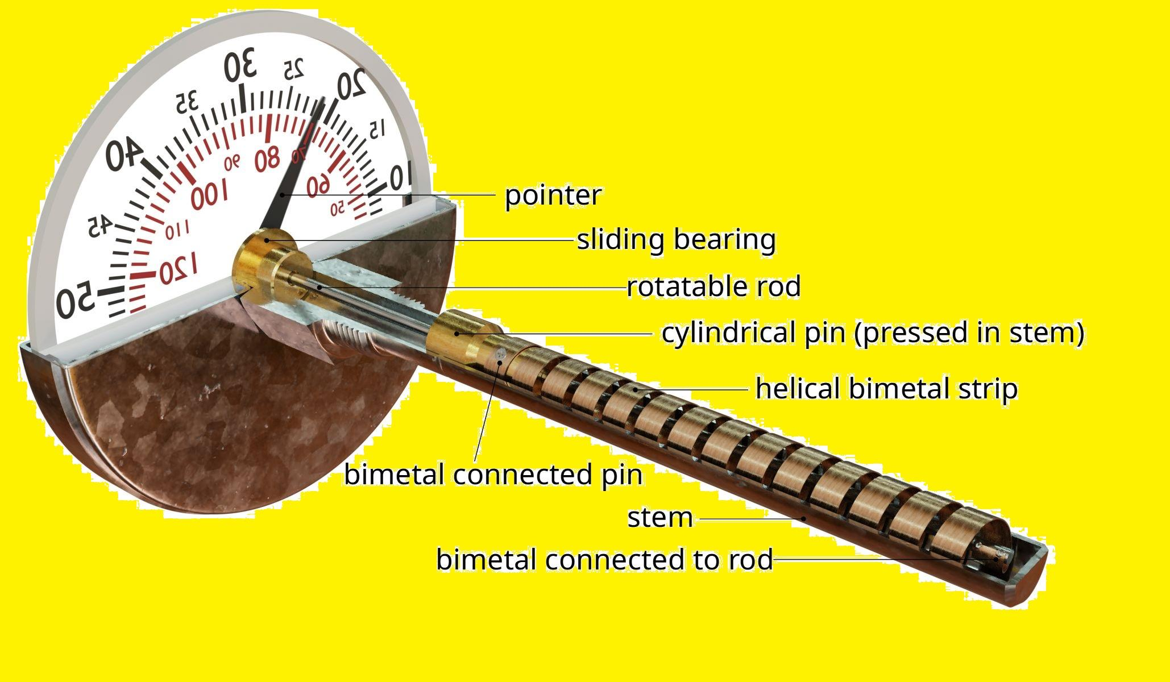
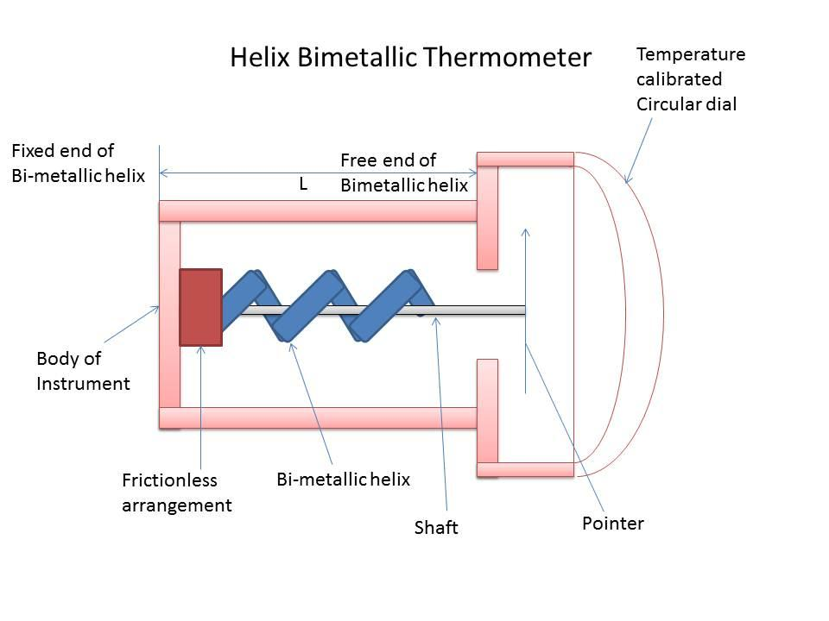
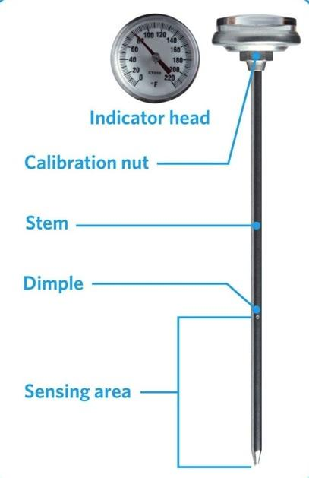
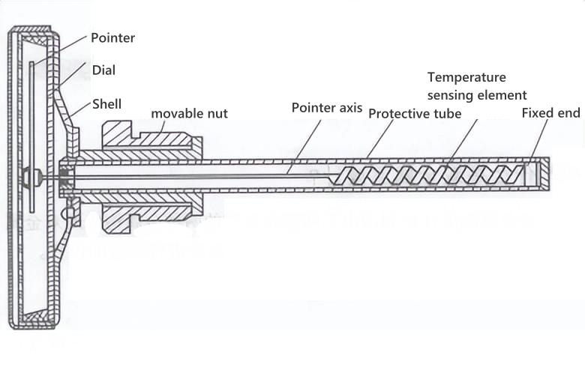
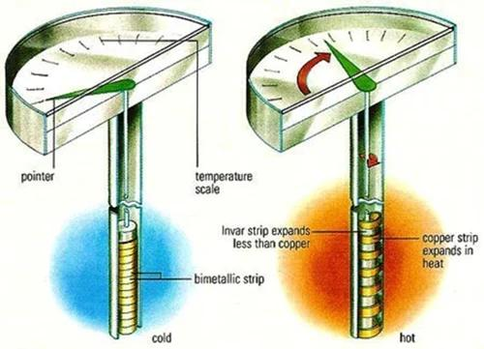
A typical bimetallic thermometer consists of:
- Bimetallic strip or spiral coil
- Temperature sensing stem
- Pointer
- Dial scale
- Protective housing
- Glass or plastic window

Types of Bimetallic Thermometers

1. Dial Bimetallic Thermometer
# Source: AI Source: Provided by: [Data Path: Persons Table -> ID Column: 1, Name_En Column: Motasem Essam] -> From: [ChatGPT] on [7/17/2026]
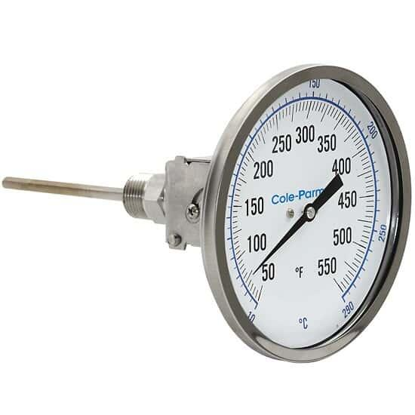
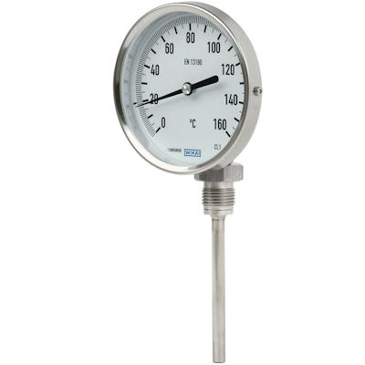
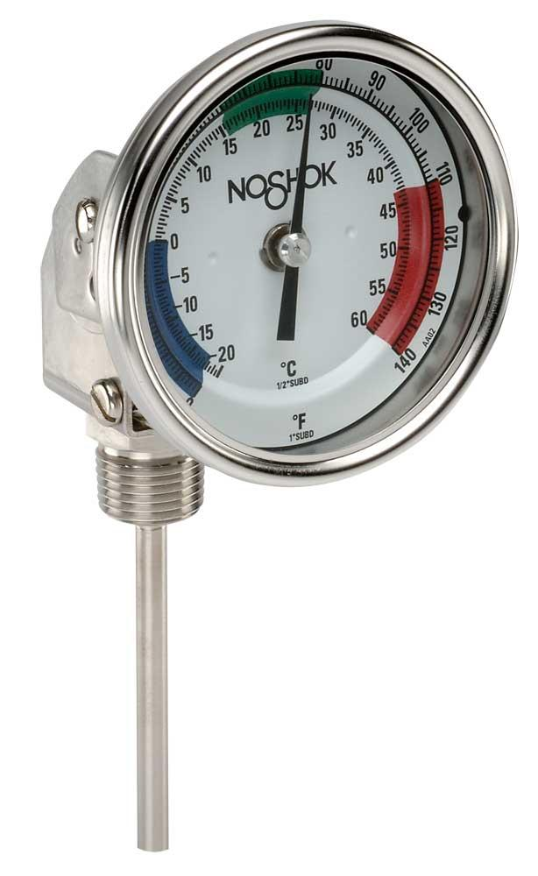
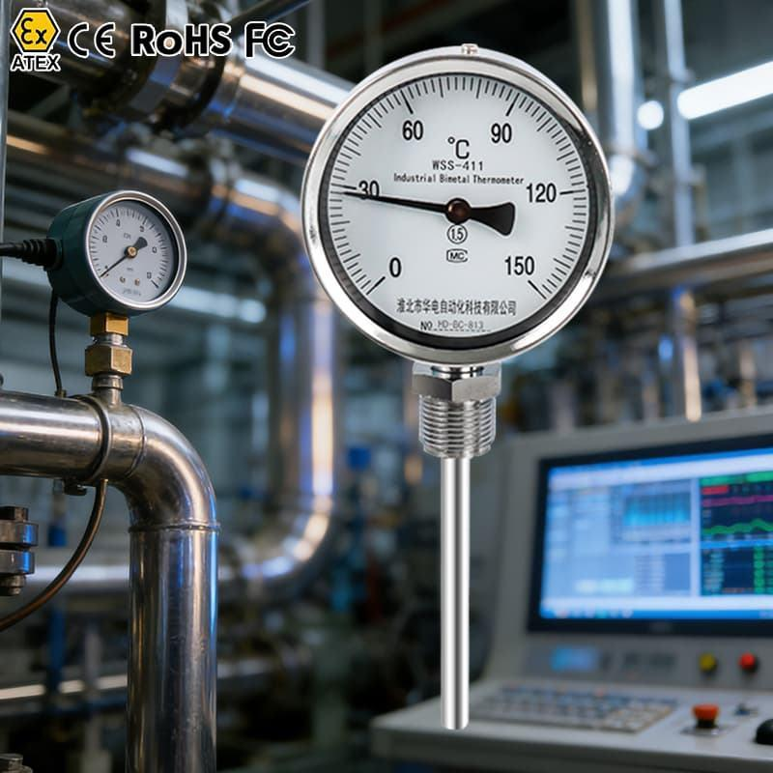
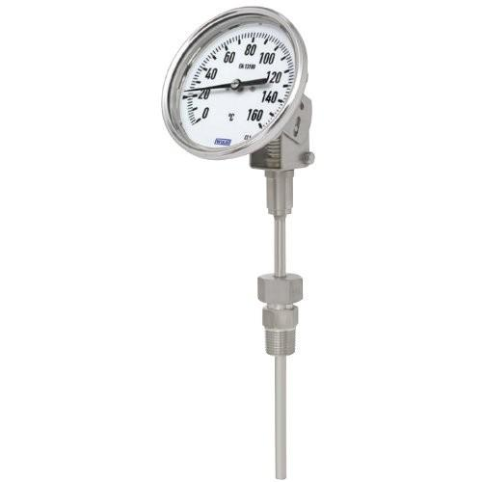
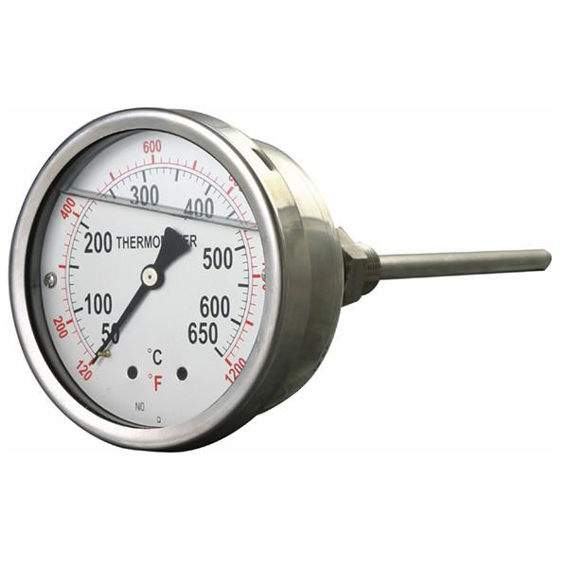
Description
The most common type, featuring a circular dial and pointer for reading temperature.
Applications
- Boilers
- HVAC systems
- Industrial machinery
- Food processing

2. Stem Bimetallic Thermometer
# Source: AI Source: Provided by: [Data Path: Persons Table -> ID Column: 1, Name_En Column: Motasem Essam] -> From: [ChatGPT] on [7/17/2026]

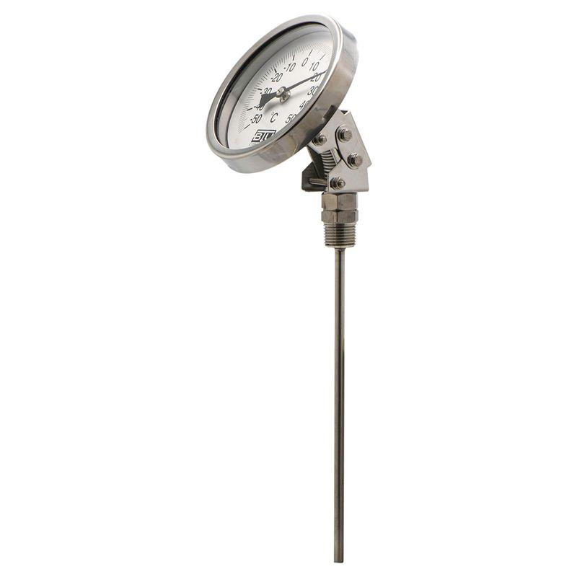
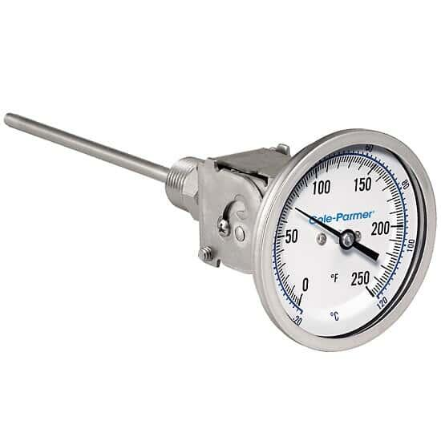
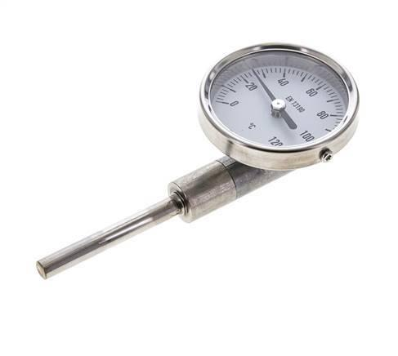

Description
Has a long sensing stem that is inserted directly into liquids or gases.
Applications
- Pipelines
- Storage tanks
- Industrial process control
- Laboratories

3. Oven Bimetallic Thermometer
# Source: AI Source: Provided by: [Data Path: Persons Table -> ID Column: 1, Name_En Column: Motasem Essam] -> From: [ChatGPT] on [7/17/2026]

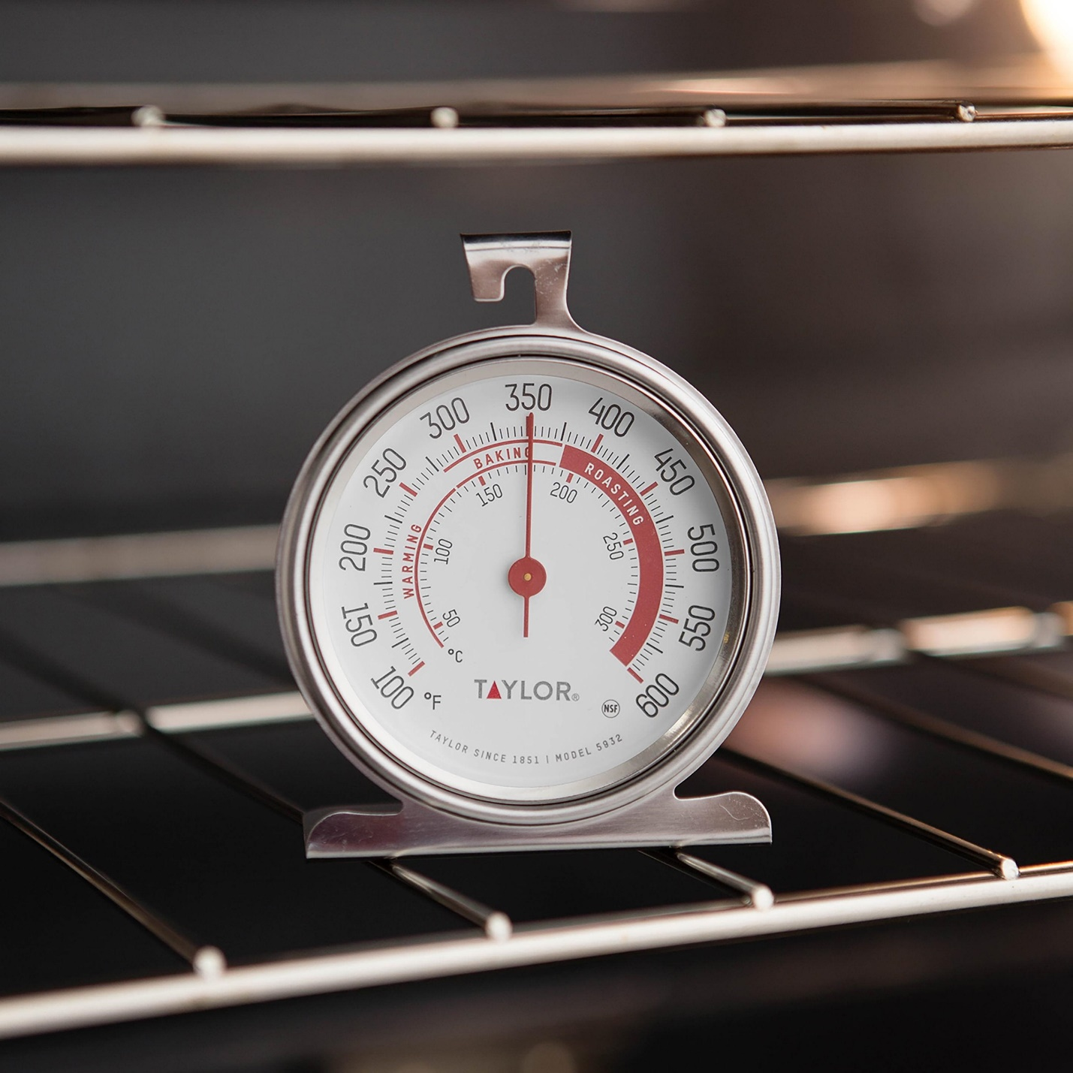
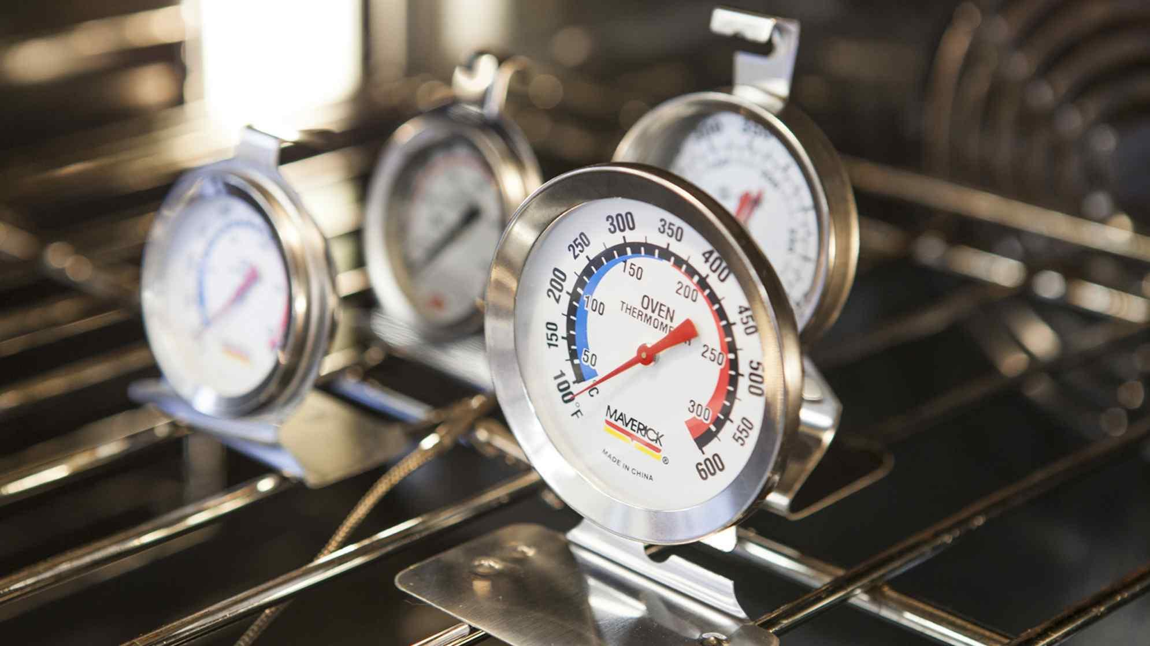
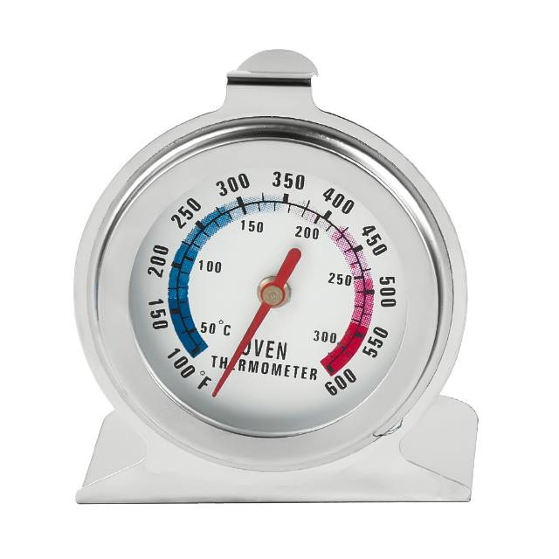
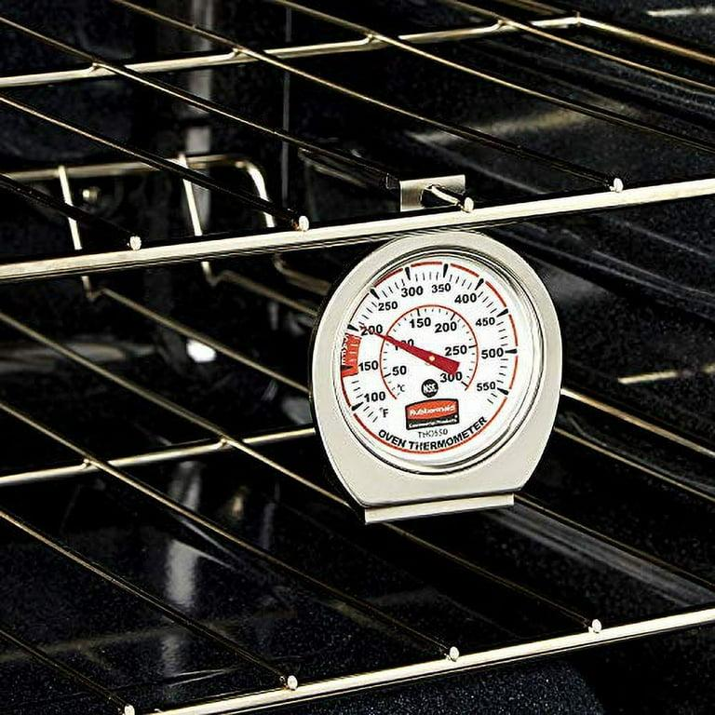
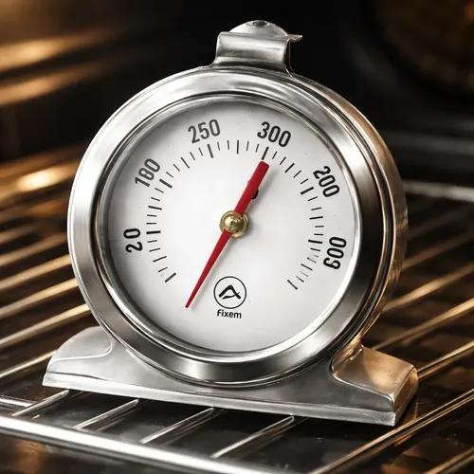
Description
Designed specifically to measure the temperature inside ovens.
Applications
- Domestic ovens
- Commercial kitchens
- Bakeries
- Food preparation

4. Surface Bimetallic Thermometer
# Source: AI Source: Provided by: [Data Path: Persons Table -> ID Column: 1, Name_En Column: Motasem Essam] -> From: [ChatGPT] on [7/17/2026]
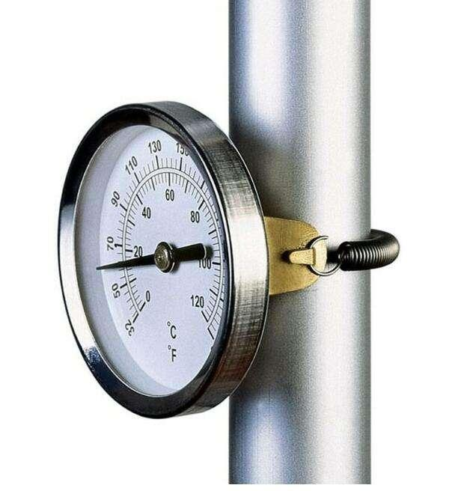
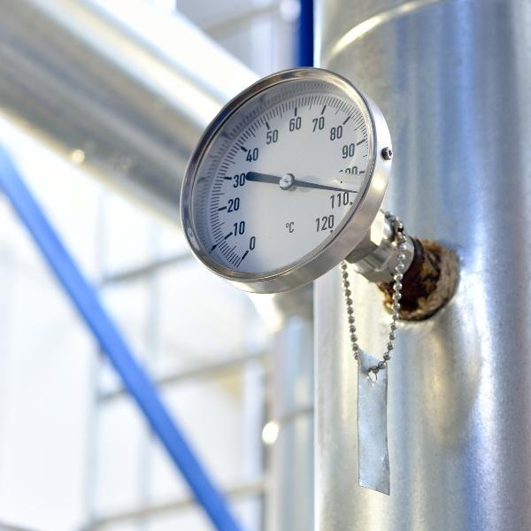
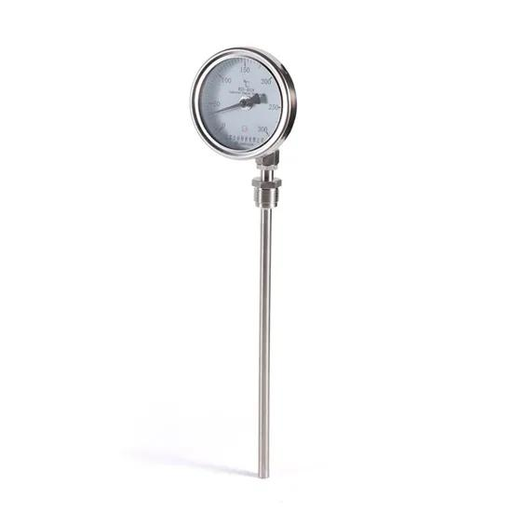
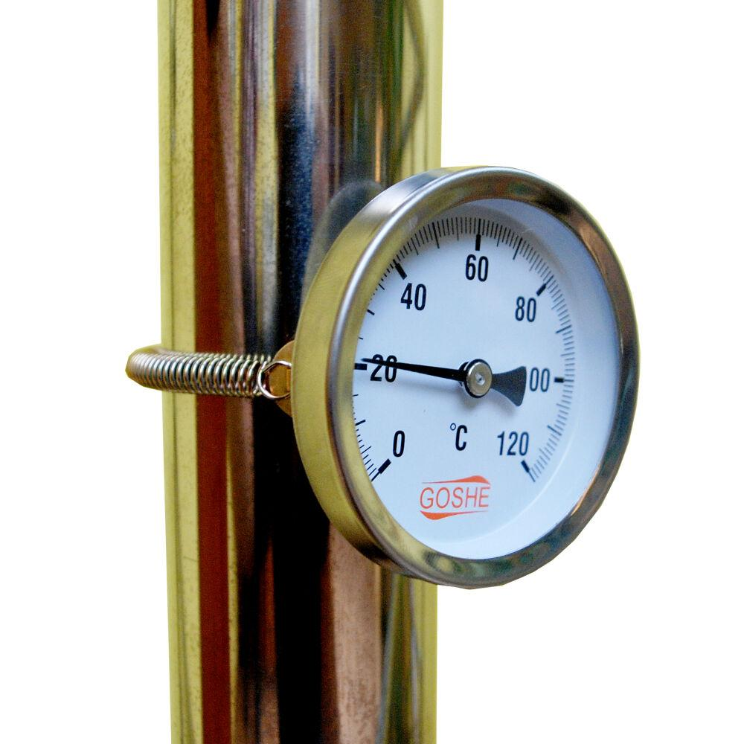
Description
Measures the surface temperature of pipes, tanks, and machinery by making direct contact with the surface.
Applications
- Pipe temperature monitoring
- Heat exchangers
- Industrial maintenance
- HVAC systems

Measuring Units
# Source: AI Source: Provided by: [Data Path: Persons Table -> ID Column: 1, Name_En Column: Motasem Essam] -> From: [ChatGPT] on [7/17/2026]
Bimetallic thermometers commonly display:
- Degree Celsius (°C)
- Degree Fahrenheit (°F)

Measuring Range
# Source: AI Source: Provided by: [Data Path: Persons Table -> ID Column: 1, Name_En Column: Motasem Essam] -> From: [ChatGPT] on [7/17/2026]
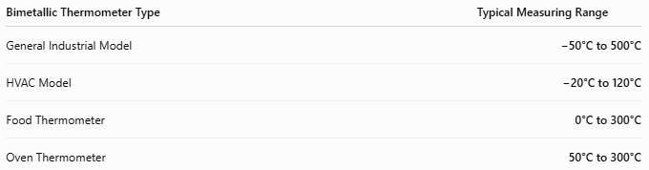
Bimetallic Thermometer Type | Typical Measuring Range
General Industrial Model | −50°C to 500°C
HVAC Model | −20°C to 120°C
Food Thermometer | 0°C to 300°C
Oven Thermometer | 50°C to 300°C

Resolution
# Source: AI Source: Provided by: [Data Path: Persons Table -> ID Column: 1, Name_En Column: Motasem Essam] -> From: [ChatGPT] on [7/17/2026]
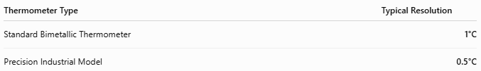
Thermometer Type | Typical Resolution
Standard Bimetallic Thermometer | 1°C
Precision Industrial Model | 0.5°C

Accuracy
# Source: AI Source: Provided by: [Data Path: Persons Table -> ID Column: 1, Name_En Column: Motasem Essam] -> From: [ChatGPT] on [7/17/2026]
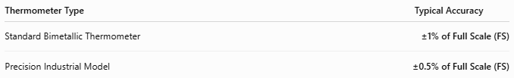
Thermometer Type | Typical Accuracy
Standard Bimetallic Thermometer | ±1% of Full Scale (FS)
Precision Industrial Model | ±0.5% of Full Scale (FS)
Notes
- Bimetallic thermometers are less accurate than RTDs and digital thermometers, but they are highly durable and reliable.
- Accuracy depends on proper calibration, installation, and operating conditions.
- Because they require no electrical power, they are ideal for continuous industrial monitoring.

How to Use a Bimetallic Thermometer
# Source: AI Source: Provided by: [Data Path: Persons Table -> ID Column: 1, Name_En Column: Motasem Essam] -> From: [ChatGPT] on [7/17/2026]
- Install or insert the sensing stem into the medium.
- Allow the thermometer to reach thermal equilibrium.
- Read the temperature from the dial.
- Record the measurement if required.

Applications
# Source: AI Source: Provided by: [Data Path: Persons Table -> ID Column: 1, Name_En Column: Motasem Essam] -> From: [ChatGPT] on [7/17/2026]
Bimetallic thermometers are used in:
- HVAC systems
- Boilers
- Refrigeration
- Food processing
- Chemical processing
- Industrial plants
- Water treatment
- Ovens
- Heating systems

Advantages
# Source: AI Source: Provided by: [Data Path: Persons Table -> ID Column: 1, Name_En Column: Motasem Essam] -> From: [ChatGPT] on [7/17/2026]
A bimetallic thermometer:
- Requires no electricity.
- Is durable and rugged.
- Is inexpensive.
- Has a simple mechanical design.
- Operates reliably in harsh environments.

Limitations
# Source: AI Source: Provided by: [Data Path: Persons Table -> ID Column: 1, Name_En Column: Motasem Essam] -> From: [ChatGPT] on [7/17/2026]
A bimetallic thermometer:
- Is less accurate than electronic thermometers.
- Responds more slowly to temperature changes.
- Has limited precision.
- Can be affected by vibration.

Sources of Error
# Source: AI Source: Provided by: [Data Path: Persons Table -> ID Column: 1, Name_En Column: Motasem Essam] -> From: [ChatGPT] on [7/17/2026]
Instrument Errors
- Calibration drift
- Metal fatigue
- Pointer wear

User Errors
- Incorrect installation depth
- Reading from an angle (parallax error)
- Measuring before stabilization

Environmental Errors
- Vibration
- Mechanical shock
- Rapid temperature fluctuations
- Corrosive environments

Comparison with Other Temperature Measuring Instruments
# Source: AI Source: Provided by: [Data Path: Persons Table -> ID Column: 1, Name_En Column: Motasem Essam] -> From: [ChatGPT] on [7/17/2026]
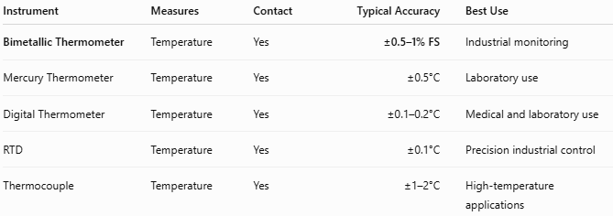
Instrument | Measures | Contact | Typical Accuracy | Best Use
Bimetallic Thermometer | Temperature | Yes | ±0.5–1% FS | Industrial monitoring
Mercury Thermometer | Temperature | Yes | ±0.5°C | Laboratory use
Digital Thermometer | Temperature | Yes | ±0.1–0.2°C | Medical and laboratory use
RTD | Temperature | Yes | ±0.1°C | Precision industrial control
Thermocouple | Temperature | Yes | ±1–2°C | High-temperature applications

Care and Maintenance
# Source: AI Source: Provided by: [Data Path: Persons Table -> ID Column: 1, Name_En Column: Motasem Essam] -> From: [ChatGPT] on [7/17/2026]
To maintain accuracy:
- Keep the sensing stem clean.
- Avoid bending the stem.
- Calibrate periodically.
- Protect from strong impacts.
- Store in a dry environment.

Common Mistakes
# Source: AI Source: Provided by: [Data Path: Persons Table -> ID Column: 1, Name_En Column: Motasem Essam] -> From: [ChatGPT] on [7/17/2026]
- Installing the stem too shallow.
- Reading the dial before stabilization.
- Exceeding the maximum temperature range.
- Ignoring calibration requirements.

Key Points
# Source: AI Source: Provided by: [Data Path: Persons Table -> ID Column: 1, Name_En Column: Motasem Essam] -> From: [ChatGPT] on [7/17/2026]
- A Bimetallic Thermometer measures temperature using thermal expansion of two bonded metals.
- Common types include:
  - Dial Bimetallic Thermometer
  - Stem Bimetallic Thermometer
  - Oven Thermometer
  - Surface Bimetallic Thermometer
- Common units:
  - °C
  - °F

Conclusion
# Source: AI Source: Provided by: [Data Path: Persons Table -> ID Column: 1, Name_En Column: Motasem Essam] -> From: [ChatGPT] on [7/17/2026]
A Bimetallic Thermometer is a robust mechanical temperature-measuring instrument that operates using the different expansion rates of two bonded metals. Its simplicity, durability, and independence from electrical power make it an excellent choice for industrial equipment, HVAC systems, boilers, refrigeration, ovens, and food processing, where reliable continuous temperature monitoring is required.

